**Equations – Self-supervised learning**

**Self-supervised learning I**

**Context-Based Methods**

* Image rotations
* Image colorization
* Jigsaw Puzzles
* Context Prediction

**Contrastive learning**

Definitions:

* “[…] trains models by maximizing the similarity between related data points while minimizing the similarity between unrelated ones.”
* “[…] to learn high-quality representations by ensuring that similar samples have closer representations while dissimilar samples are pushed apart in the feature space.”

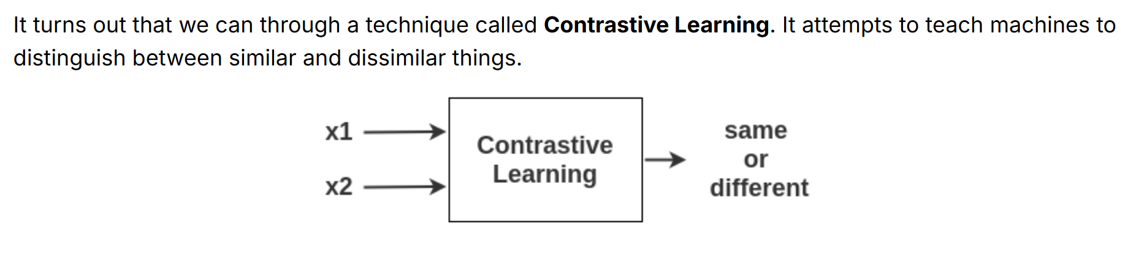

**SimCLR (2020)**

* A simple framework for contrastive learning of visual representations.

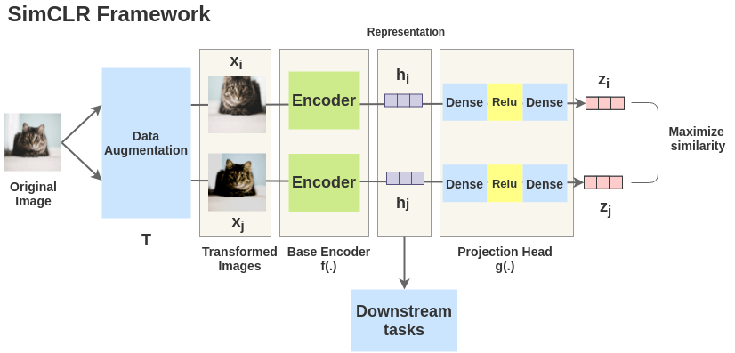

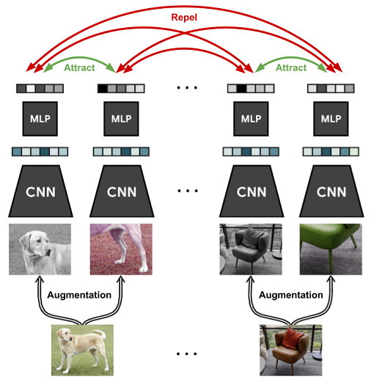

Normalized Temperature-scaled Cross-Entropy (NT-Xent)

**MoCo (2020)**

Contrastive loss:

* “[…] function whose value is low when $q$ is similar to its positive key $k^{+}$ and dissimilar to all the other keys.”

Momentum update

$k^{+}$ matches $q$

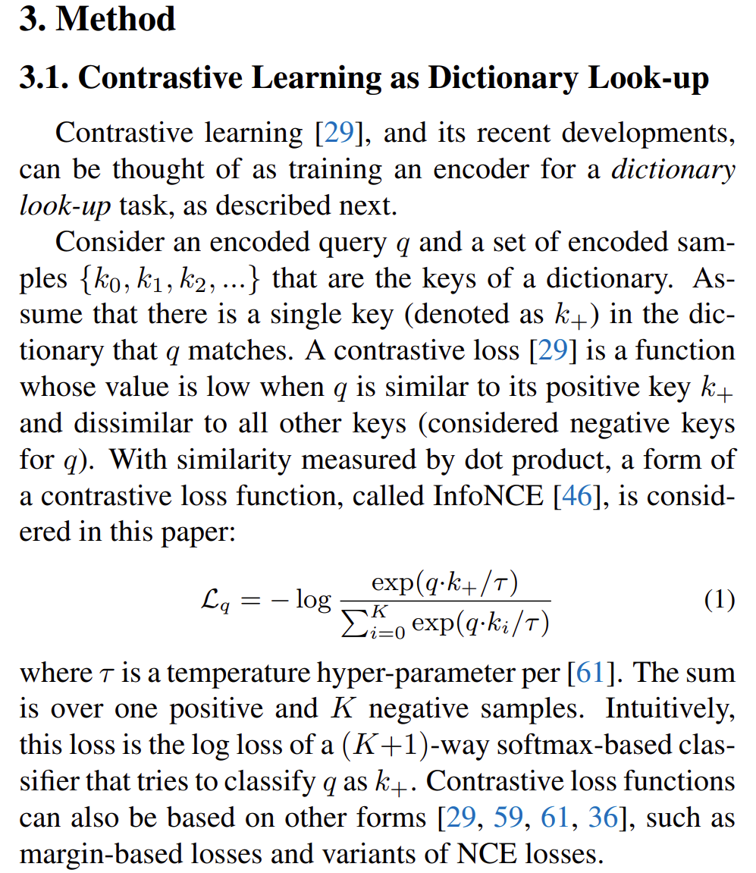

**CPC (2018)**

Representation Learning with Contrastive Predictive Coding

Learns useful representations from high-dimensional data. Learns by predicting the future in latent space by using autoregressive models.

Shared information

Mutual information: $I\left(x,y\right)$

Maximize mutual information.

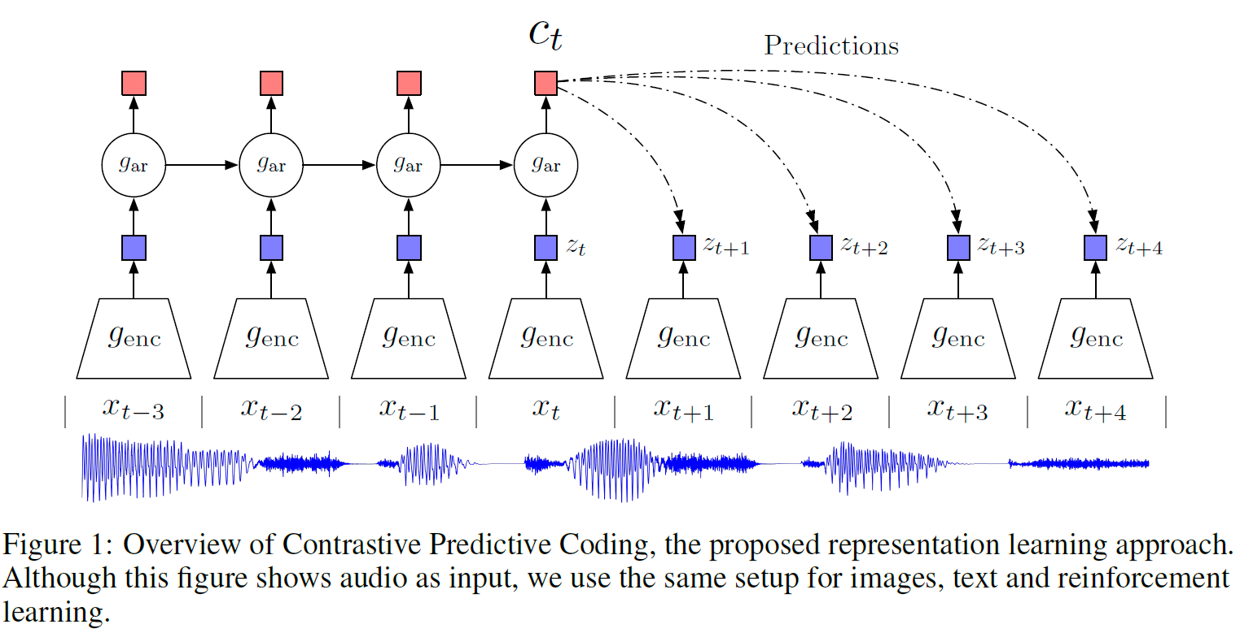

**BYOL (2020)**

After training, BYOL produces good representations $y_{θ}$ for downstream tasks.

Architecture

* Set of images $D.$ Image $x∼D$ sampled uniformly from $D$.
* $T, T'$ distributions of image augmentations. $t∼T, t^{'}∼T'$ image augmentations.
* $v≜t\left(x\right), v'≜t'\left(x\right)$ augmented views.
* **Online network** outputs representation $y_{θ}≜f_{θ}\left(v\right)$ and a projection $z_{θ}≜g_{θ}\left(y\right)$
* **Target network** outputs representation ${y'}_{ξ}≜f_{ξ}\left(v'\right)$ and the target projection ${z'}_{ξ}≜g_{ξ}\left(y'\right)$.
* **Online network** outputs a prediction $q_{θ}\left(z_{θ}\right)$ of ${z'}_{ξ}$ and normalize both.

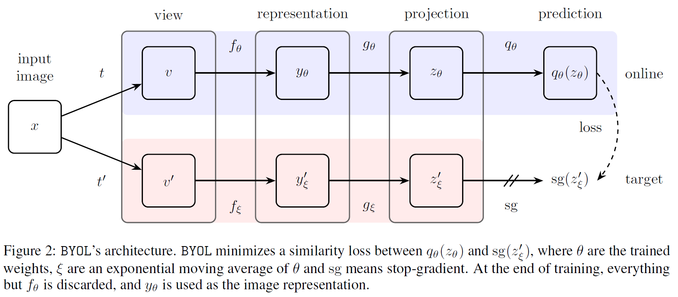

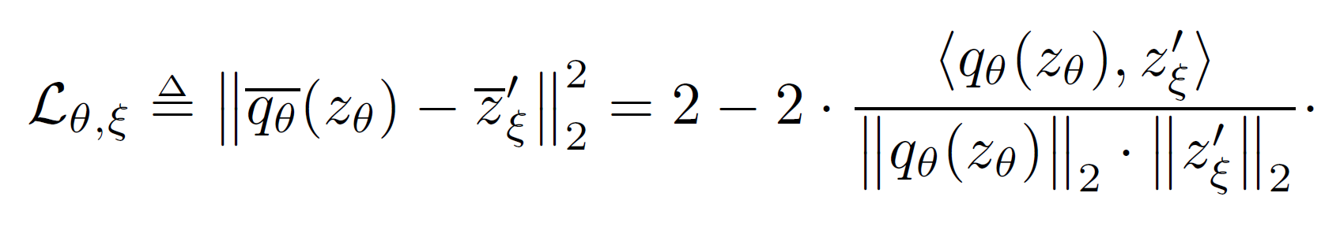

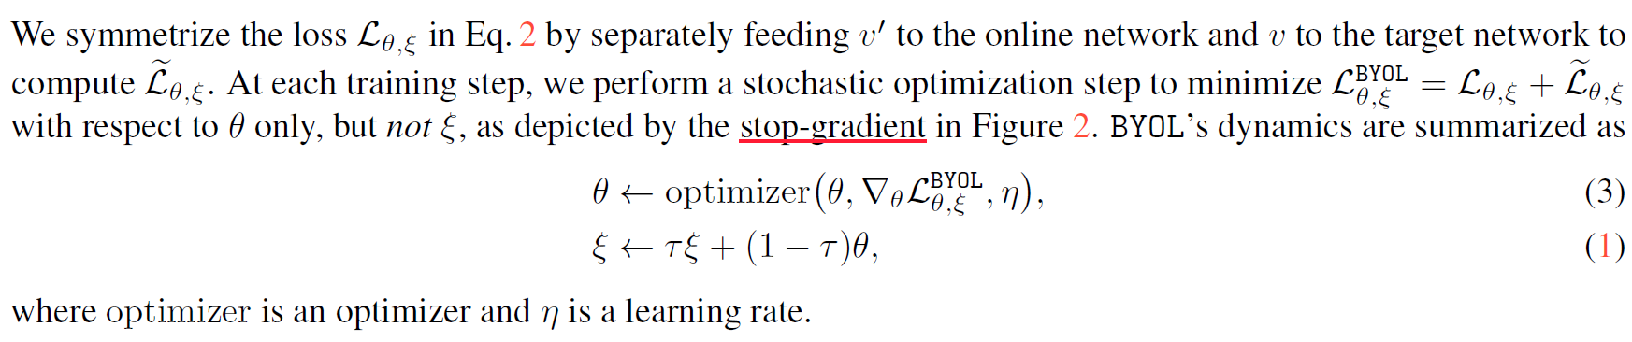

Update target network parameters using EMA

$$ξ←τξ+\left(1-τ\right)θ$$

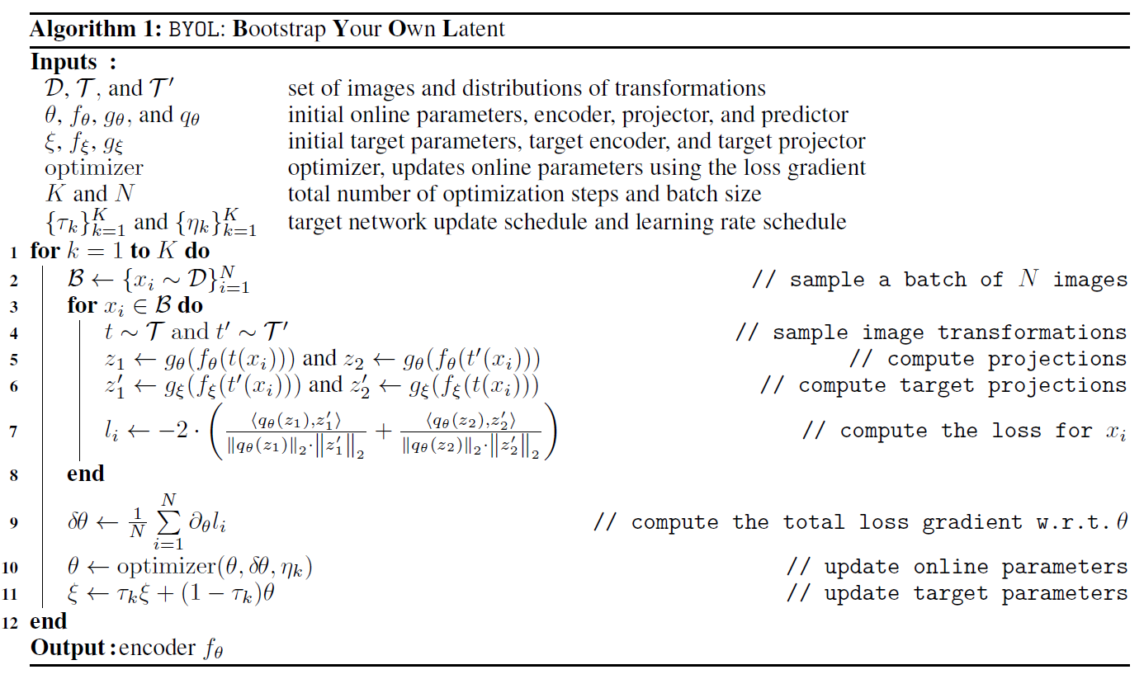

**SimSiam (2021)**

Framework

* Let $x_{1},x_{2}$ be augmented views from an image $x$.
* Encoder and a projection MLP head

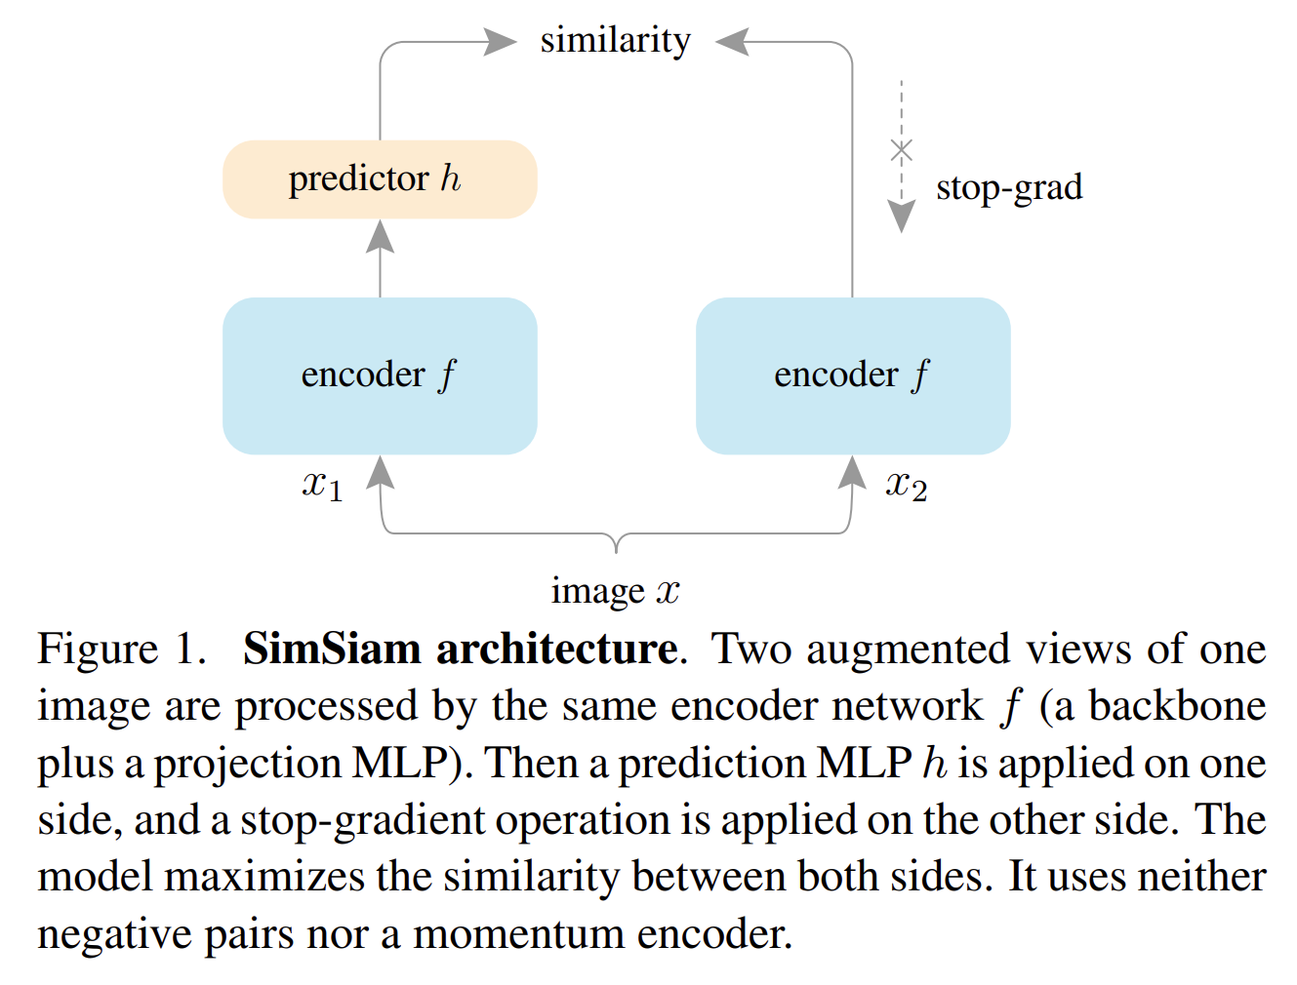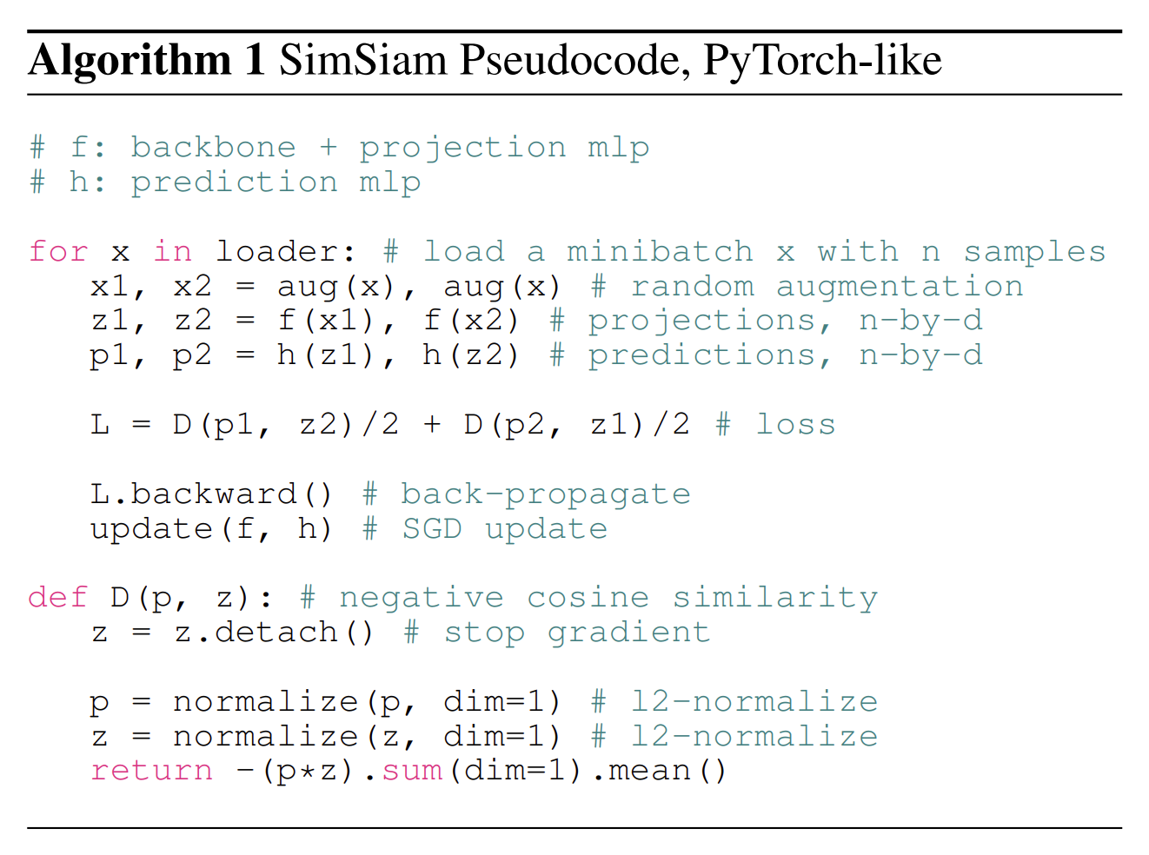

Minimize negative cosine similarity

$$D\left(p_{1},z_{2}\right)=-\frac{p_{1}}{{\left\|p_{1}\right\|}_{2}}∙\frac{z_{2}}{{\left\|z_{2}\right\|}_{2}}$$

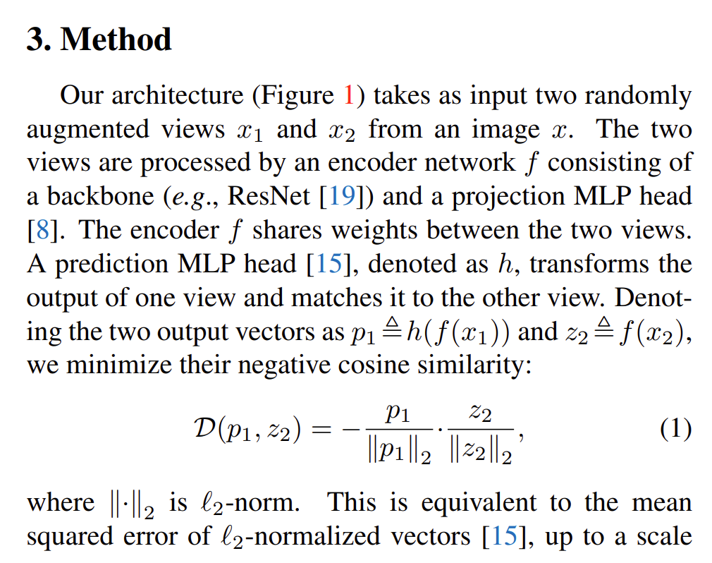

Symmetrized loss

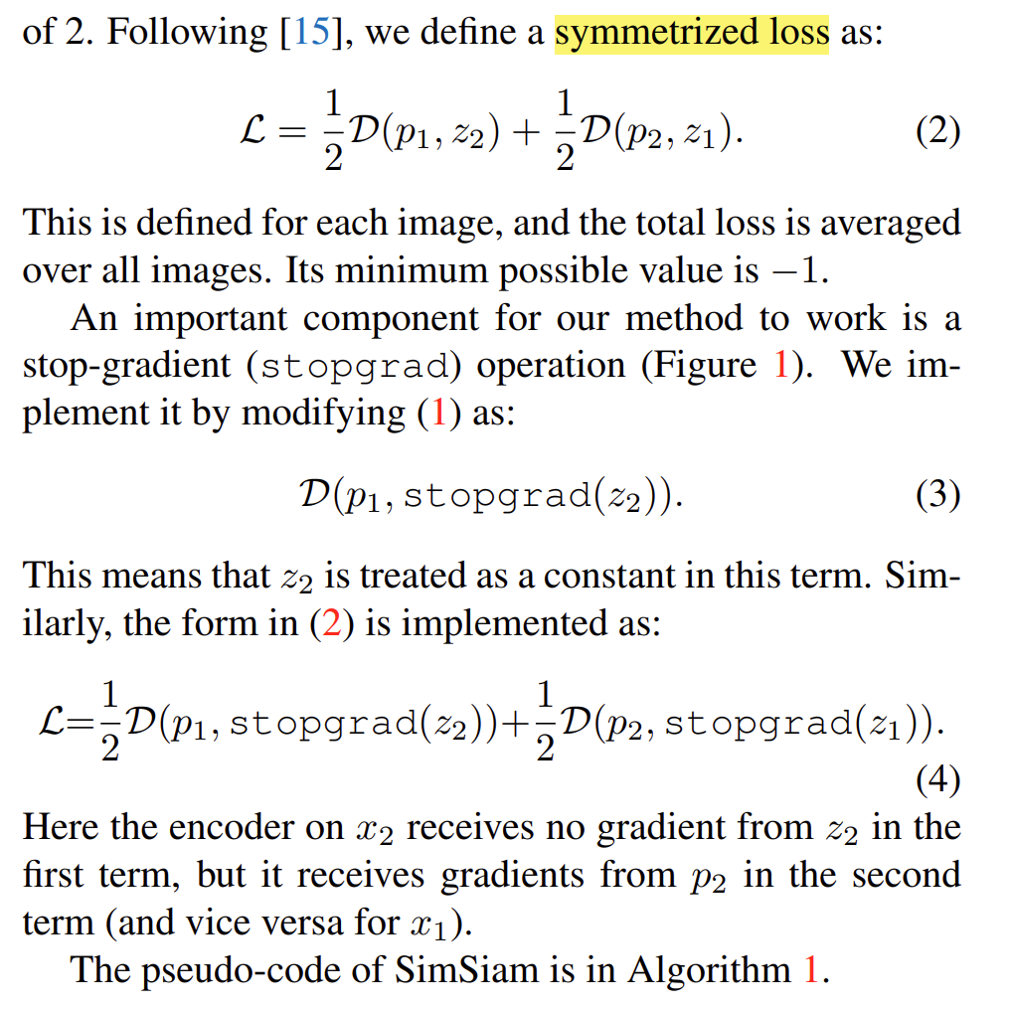

**CLIP (2021)**

* The model learns to associate images with textual descriptions.
* Uses a text encoder and an image encoder

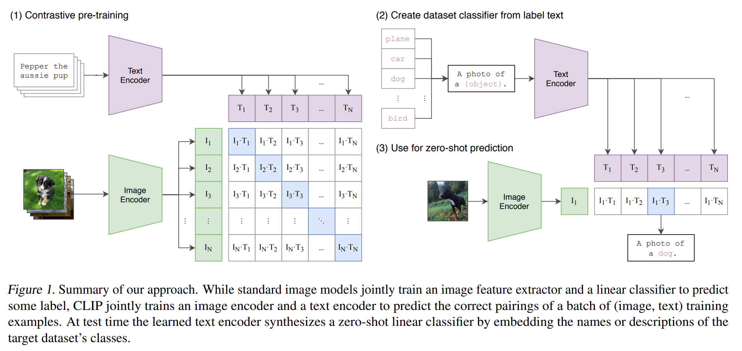

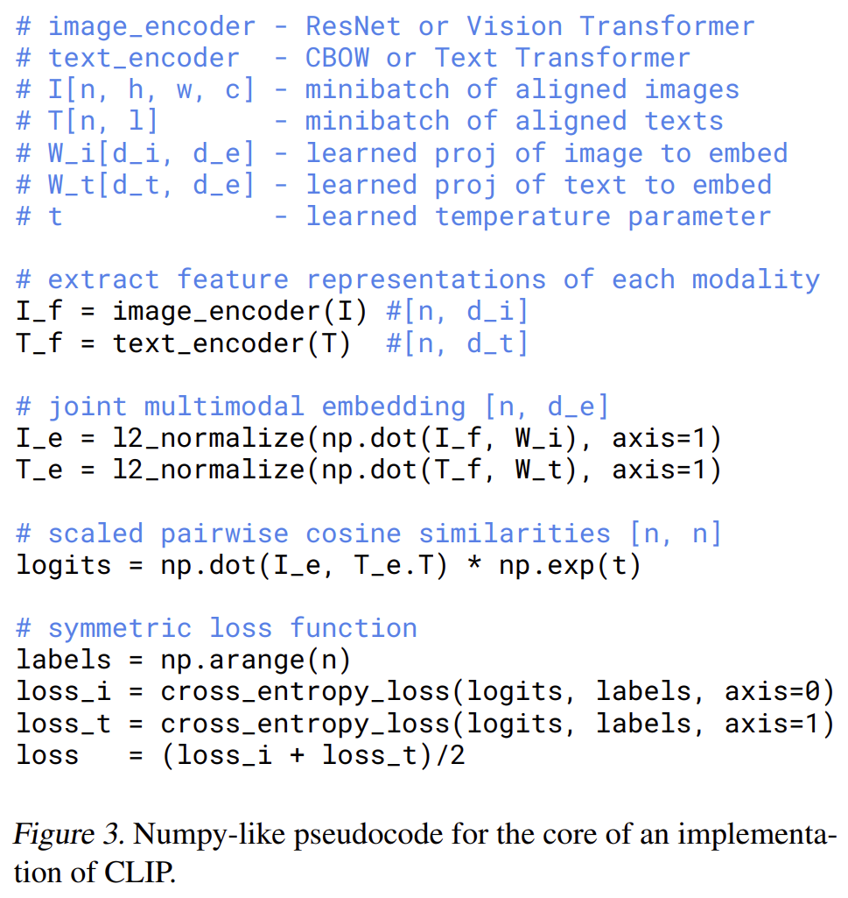

**Self-supervised learning II**

**BERT (2018)**

Framework steps:

1. Pre-training: unlabeled data, pre-training tasks (Masked LM, Next Sentence Prediction).
2. Fine-tuning: labeled data, downstream tasks, initialized with the pre-trained parameters.

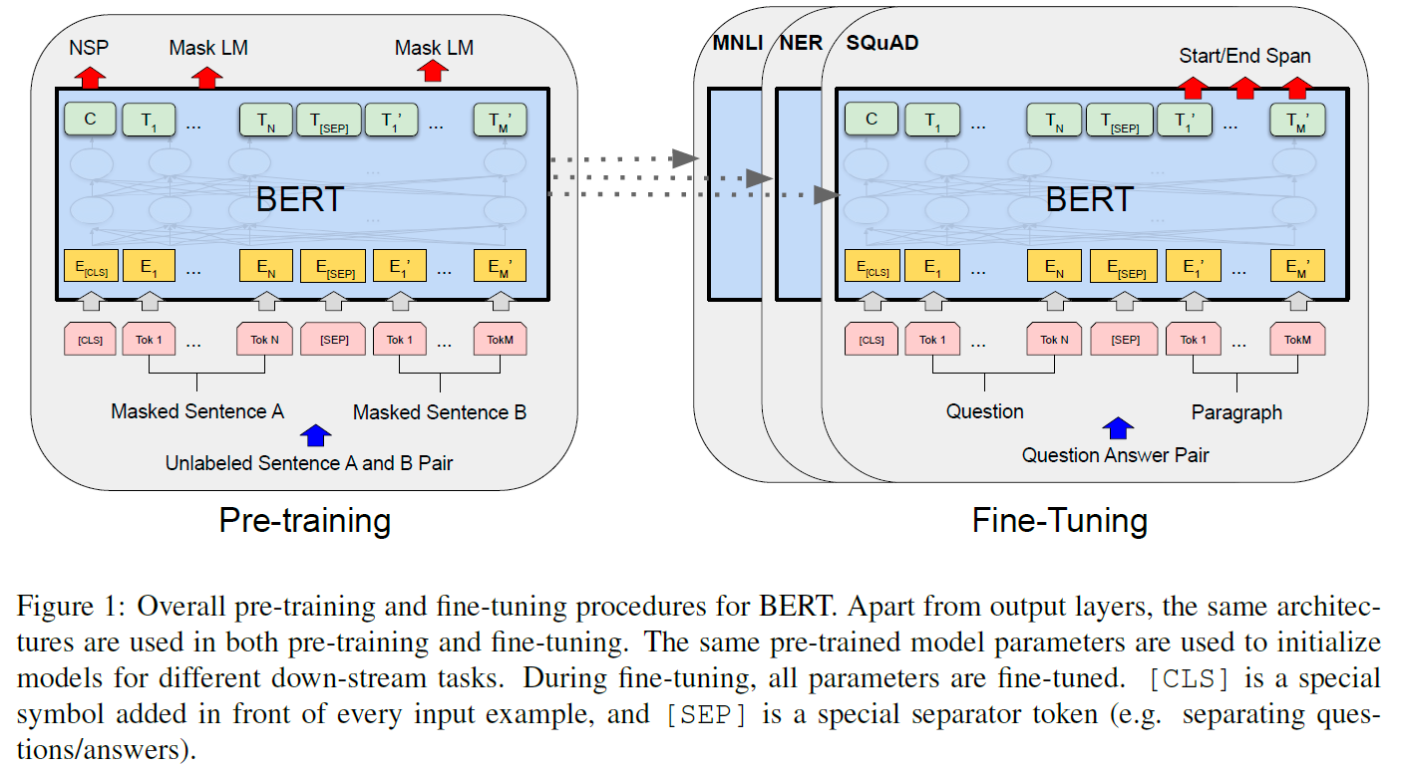

**BEiT (2021)**

* It adapts BERT's masked prediction approach to images.
* Pre training task: masked image modeling (MIM)
* Problem handled: no pre-exist vocabulary for vision Transformer’s input unit (image patches).
* Predicts **visual tokens**.
* From VAEs import VQ-VAE

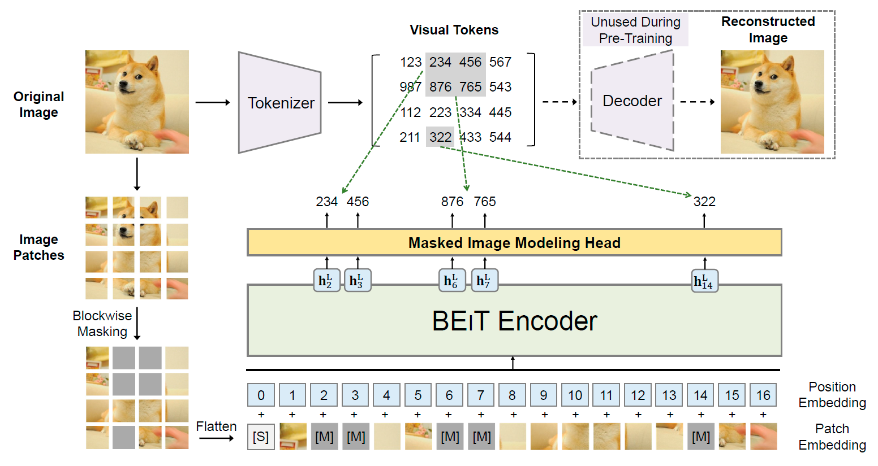

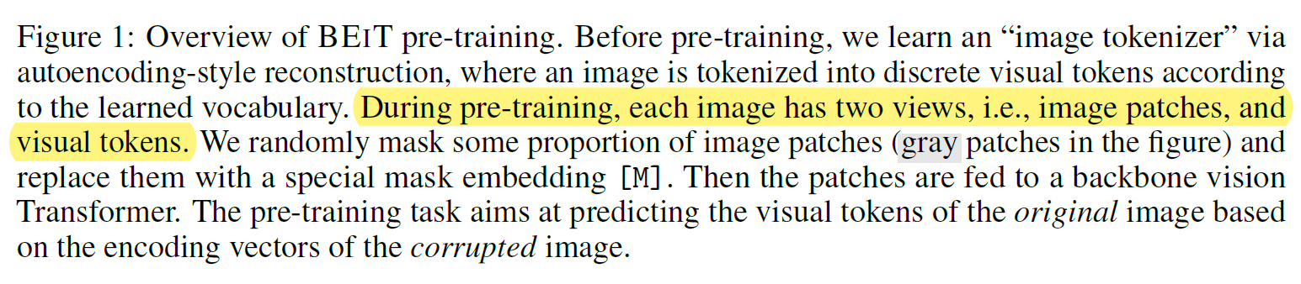

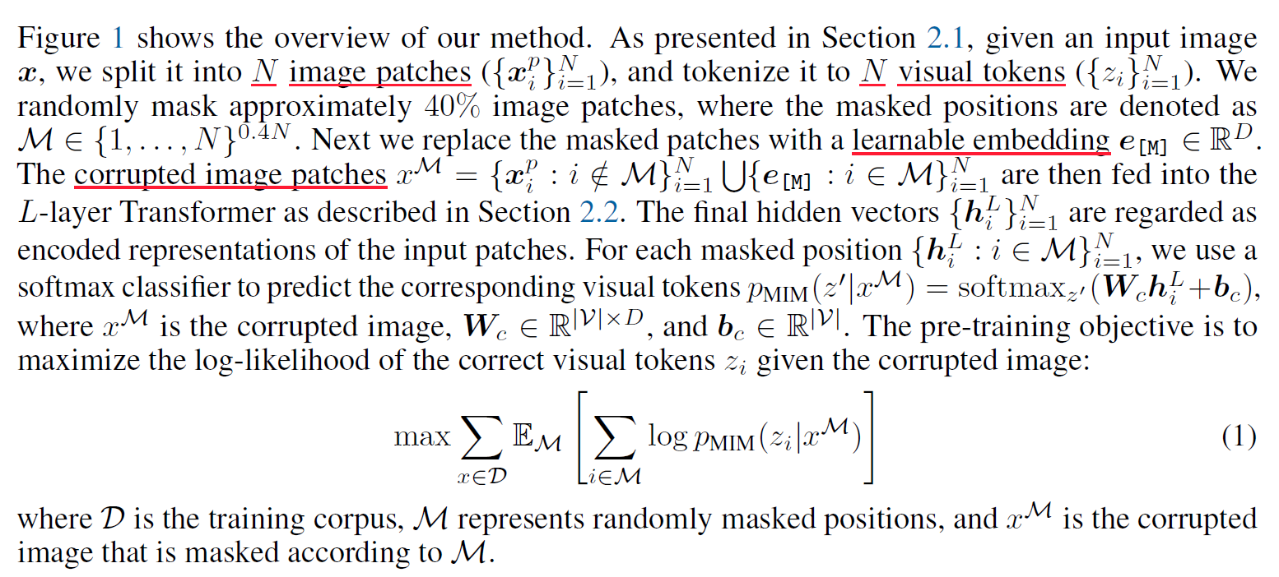

VQ-VAE (Vector Quantized-Variational Autoencoder)

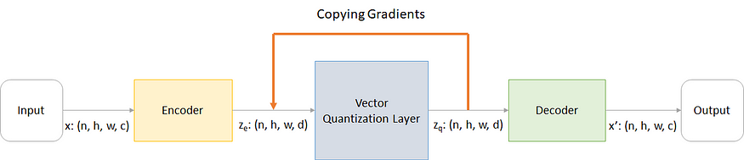

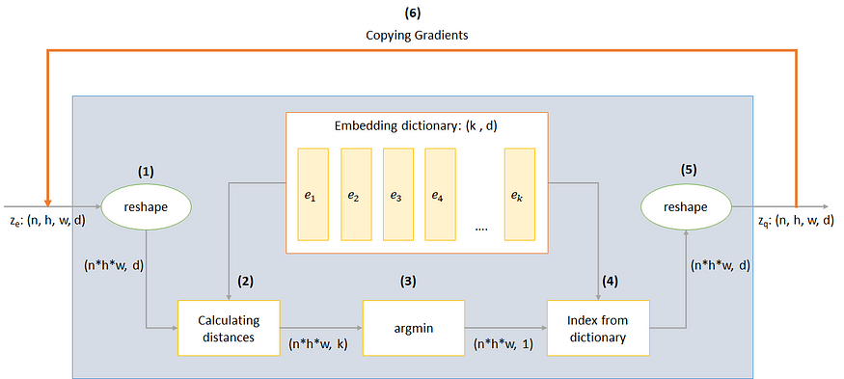

**iBOT (2022)**

Preliminaries:

Masked image modeling (MIM)

Self-distillation (proposed in DINO).

Let $u, v$ be distorted views of $x∼I$. $u, v$ are then put through a teacher-student framework to get the predictive categorical distributions from the [CLS] token. The knowledge is distilled from teacher to student by minimizing their cross-entropy:

$$L_{\left[CLS\right]}=-P_{θ^{'}}^{\left[CLS\right]}{\left(v\right)}^{T}\log{P_{θ}^{\left[CLS\right]}\left(u\right)}$$

iBOT uses ViTs as backbones.

ViT overview (CLS token, extra learnable “classification token”)

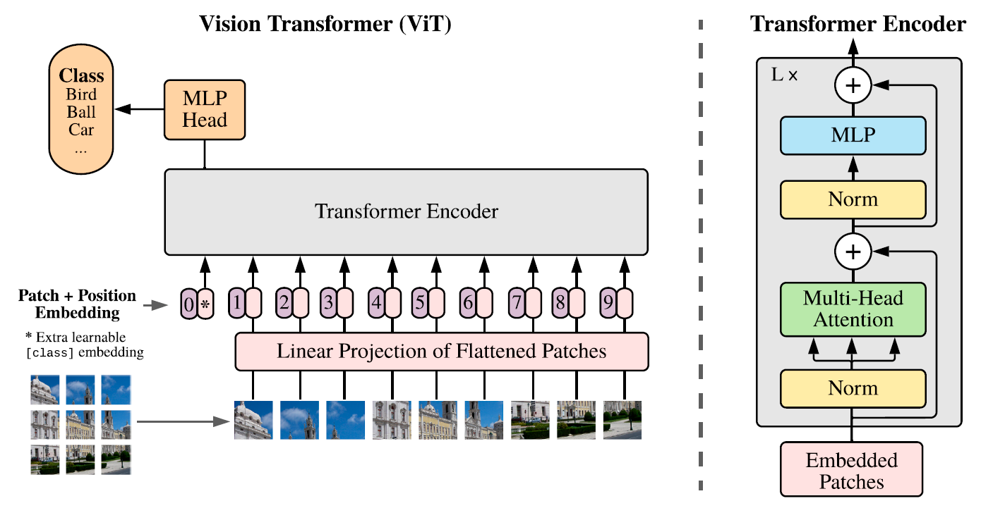

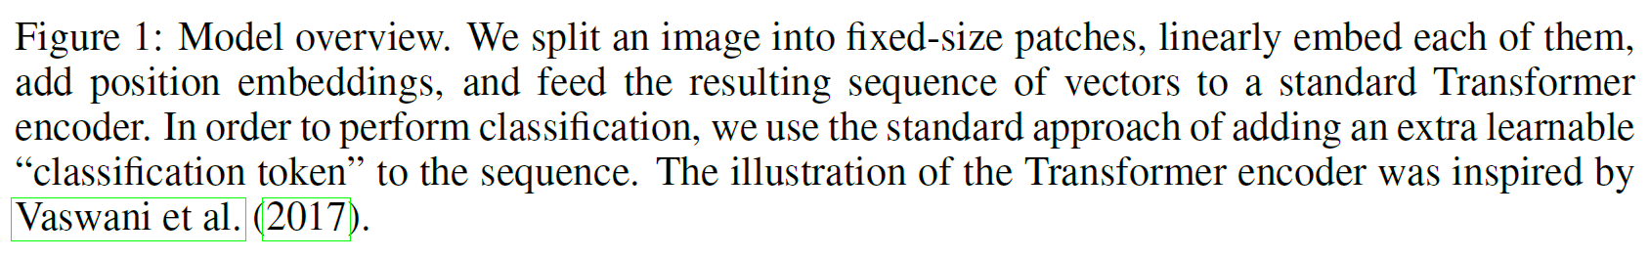

Framework

* Let $\hat{u}, \hat{v}$ be masked views.
* Student network outputs ${\hat{u}}_{s}^{patch}=P_{θ}^{patch}\left(\hat{u}\right)$
* Teacher network outputs $u_{t}^{patch}=P_{θ'}^{patch}\left(u\right)$
* Training objective of MIM in iBOT:

$$L_{MIM}=-\sum_{i=1}^{N}{m_{i}}P_{θ^{'}}^{patch}{\left(u_{i}\right)}^{T}\log{P_{θ}^{patch}\left({\hat{u}}_{i}\right)}$$

The loss symmetrized by averaging with another CE term between ${\hat{v}}_{s}^{patch}$ and $v_{t}^{patch}$.

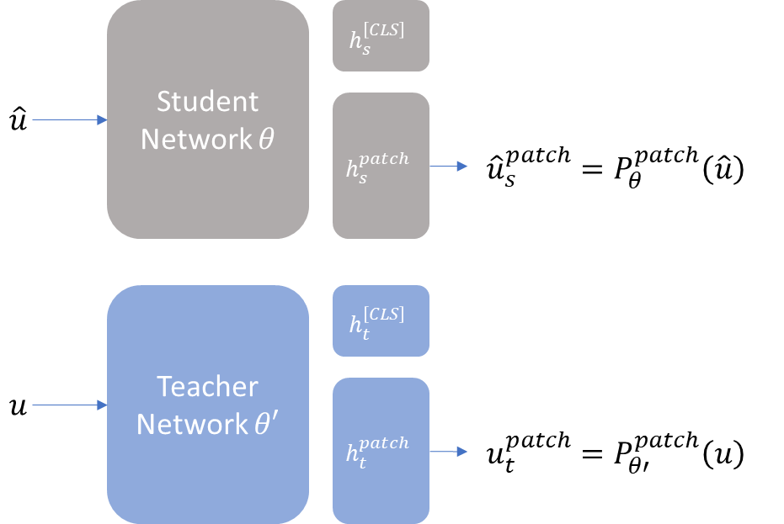

Complete pipeline

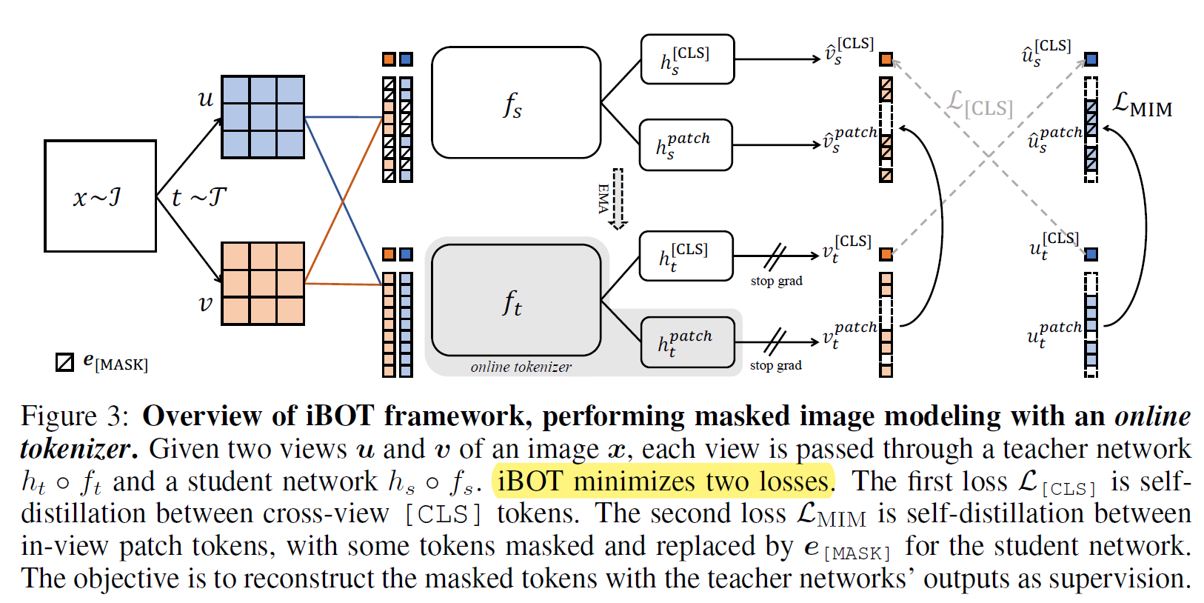

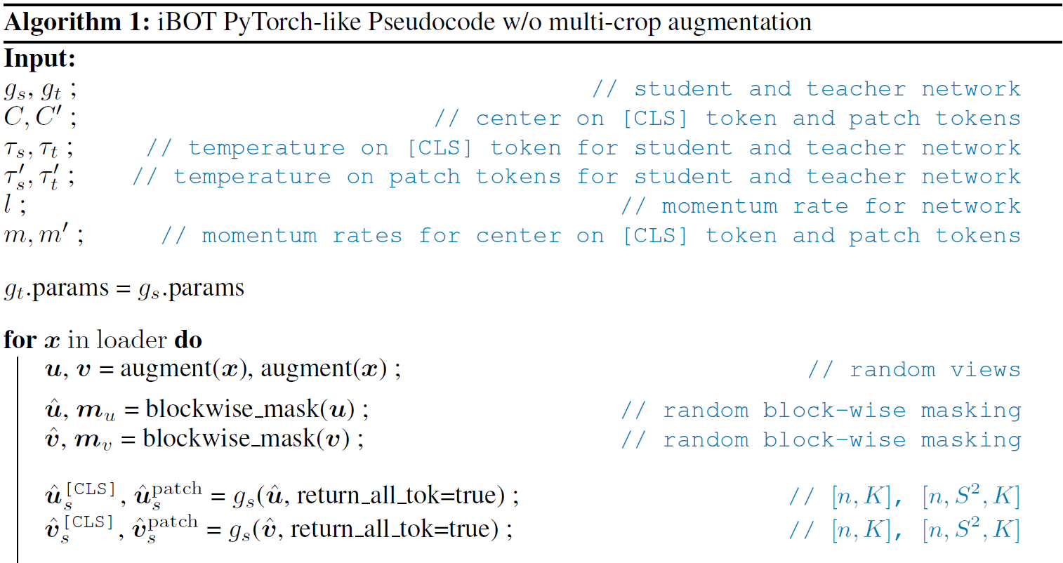

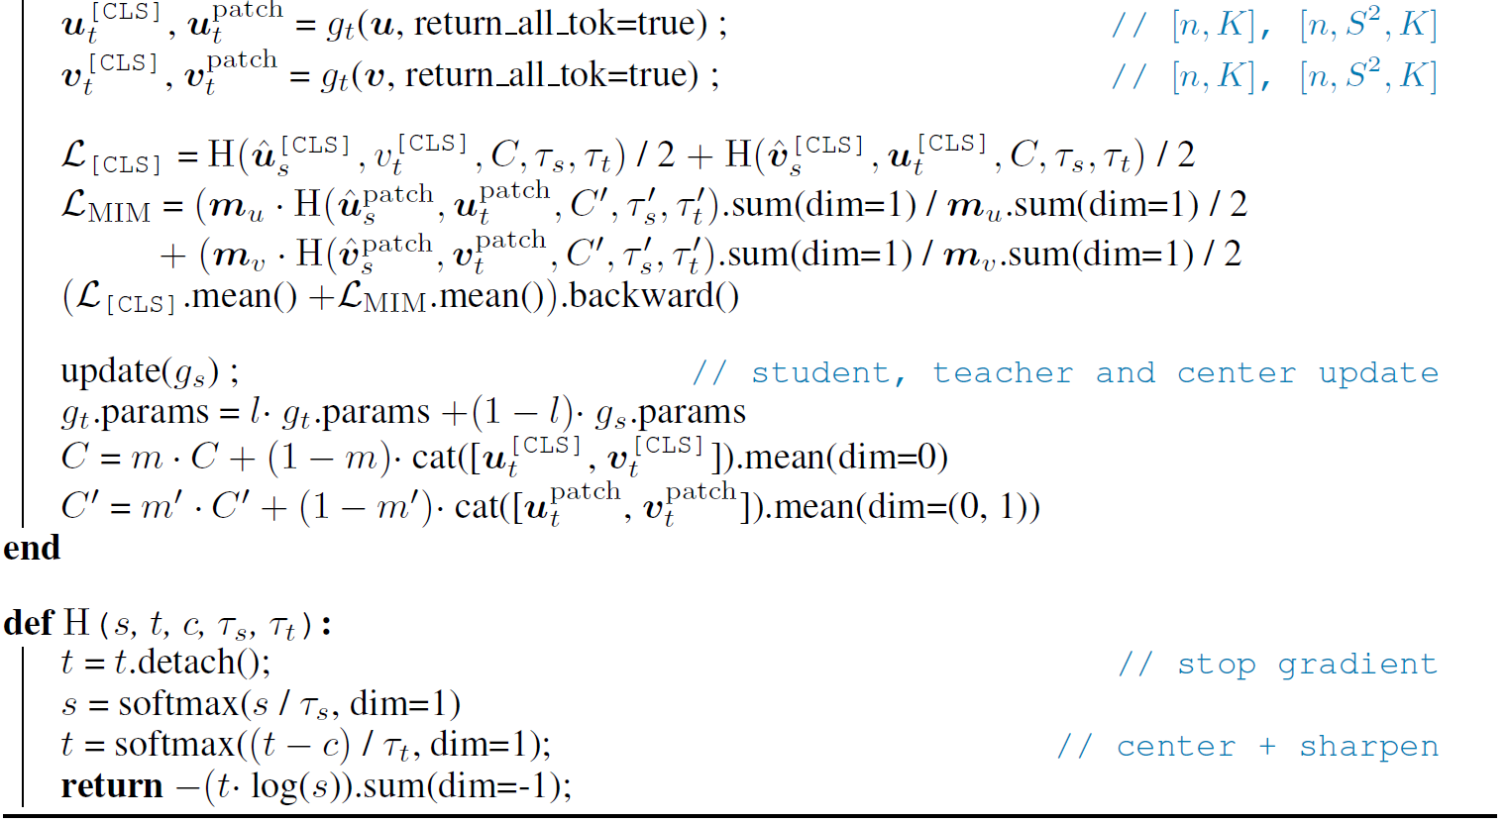

**SimMIM (2022)**

Simple Masked Image Modeling

**DINO (2021)**

Both networks produce a probability distribution $P_{s}$ and $P_{t}$ over $K$ classes using the SoftMax function.

$$P_{s}^{\left(i\right)}=\frac{\exp\left(g_{θ_{s}}{\left(x\right)}^{\left(i\right)}/ τ_{t}\right)}{\sum_{k=1}^{K}{\exp\left(g_{θ_{s}}{\left(x\right)}^{\left(k\right)}/ τ_{t}\right)}}$$

In Knowledge distillation, the student network learns using $\min_{θ_{s}}{H\left(P_{t}\left(x\right),P_{s}\left(x\right)\right)}$.

The problem is adapted to self-supervised learning using:

$$\min_{θ_{s}}{\sum_{x∈\left\{x_{1}^{g},x_{2}^{g}\right\}}{\sum_{x^{'}∈V,x'≠x}{H\left(P_{t}\left(x\right),P_{s}\left(x'\right)\right)}}}$$

Where: $V$ is a set of local and global views, $x_{1}^{g},x_{2}^{g}$ are global views.

“All crops are passed through the student while only the global views are passed through the teacher […]”

The teacher $g_{θ_{t}}$ is built from past iterations of the student (Self-distillation).

Update rule:

$$θ_{t}←λθ_{t}+\left(1-λ\right)θ_{s}$$

$λ$ follows a cosine schedule from 0.996 to 1 during training.

The framework prevents **collapse** by centering and sharpening the momentum teacher's outputs.

$$g_{t}\left(x\right)←g_{t}\left(x\right)+c$$

The center $c$ is updated with EMA.

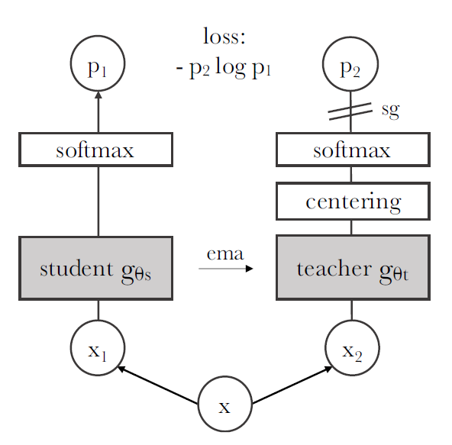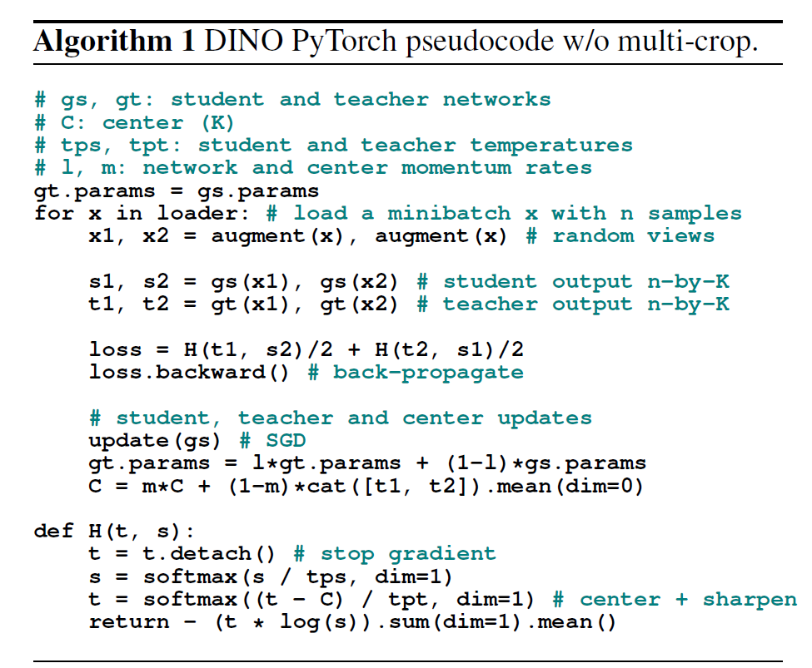

**DEiT (2021)**

Training data-efficient image transformers & distillation through attention

Vision transformer (attention layers)

**Distillation token:** on output of the network its objective is to reproduce the (hard) label predicted by the teacher, instead of true label.

**Soft distillation:** minimizes $KL\left(ψ\left(Z_{s}/τ\right),ψ\left(Z_{t}/τ\right)\right)$.

**Hard distillation:** takes the hard decision of the teacher as a true label.

